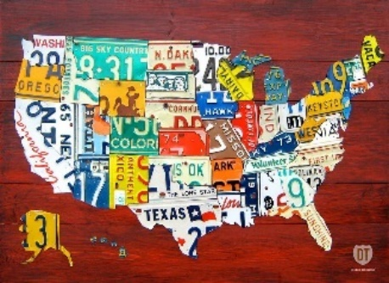
Introduction

This week you will be planning a trip anywhere in the United States with an itinerary for each day. Each day you will work on a different content area to complete the whole project. Today, you will be focusing on Social Studies and Reading.

Monday April 20th: Social Studies and Reading

Directions:

Read all the instructions and review the Resources. You have completed your work for today once you have:
- submitted your assignment
- completed your Flocabulary

Step 1: Answer the following questions on paper.
- Where are you going? (one destination or multiple places)
- How will you get to your destination? (Include a map)
- How will you travel whilst sightseeing?
- What are the advantages to your chosen form of travel? (convenience, time, sightseeing)
- What will you see each day? (include at least 2 historical places of interest, or geographic features each day)
- Where will you eat? (at least 2 meals at specific restaurants with details about type of food and menu)
- Where will you stay? (hotel, hostel, campground)
- How much will this trip cost?

Resources:
Here are some videos to support you in reading all the information you will be interacting with this week from Mrs. Whaley.

What is an itinerary? | Text features | Text Features on a Website
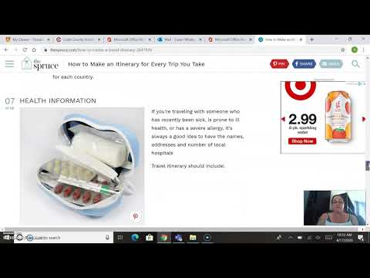 | 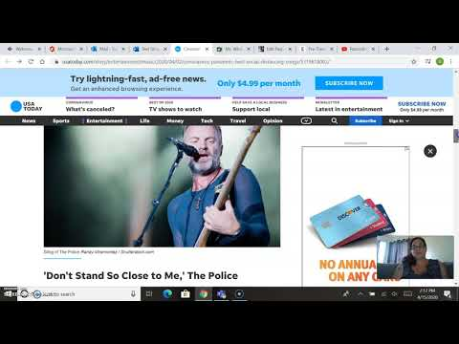 | 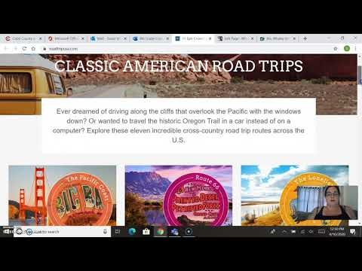

Here are some links you can visit to help you answer the questions above

Sample Itinerary | https://www.earthtrekkers.com/5-days-in-new-york-city-itinerary/
Virtual field trips to get ideas for your trip | https://www.roadtripusa.com/  https://www.thediscoveriesof.com/travel/usa-canada/
Locations, travel and hotels | https://www.google.com/maps/  https://www.tripadvisor.com/  https://www.expedia.com/
Things to do | https://www.tripadvisor.com/  https://www.viator.com/

Step 2: Present your answers
Now that you have answered your questions, decide how you are going to present your information. You can use the following formats in Office 365.
- Word
- PowerPoint
- Sway
- Microsoft Clips
Step 3: Submit your assignment.
Complete this form and upload your document.
Step 4:
Reading matters and so does practice. Complete your Flocabulary.
Spanish:
If you are Spanish student click here.

Video Chats
Today you can video chat with the following teachers:
Teacher | Time | Join Video Chat
Parker | 1:30 pm | Padlet
Warden | 1:30 pm | See Ms. Warden’s blog
Burger | To be announced | See Mr. Burger’s blog
Hubbard | To be announced | See Mr. Hubbard blog
Neal | To be announced | See Ms. Neal’s blog
Whaley | 2:00 pm | See Ms. Whaley’s blog

