STEP 2: THE MAKE POWER POINT GRAPHIC ORGANIZER

The laws of forces and motion govern the natural world around us. But as you saw in
the Mosa Mack Comic Mystery in The Solve, sometimes people don’t always
understand why things happen. Mosa used reenactments to help understand these
principles of forces and motion, so now it is your job to do the same to teach others!
Instructions:
- Log in to your Mosa Mack Account
- Click on the section for Step 2: The Make
- Complete the following graphic organizer below along with the PowerPoint (Write on this graphic organizer or on your own paper or type into the columns below).
- If you need to go back to the video and watch just click back on the animation part

Episode Motion  (With Time Code) | What forces are responsible for the motion observed? | Draw in arrows and label the force(s) acting on the object
Leaping Pickles  (2:15-2:30) | Example Answer: Applied force ( pushing of jars) Gravity
Flying Cans
(3:11-5:00)
Falling Oranges  (5:07-6:07) |  | 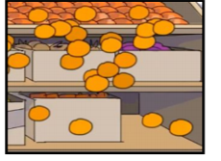
Running Red Liquid  (6:23-7:50) |  | 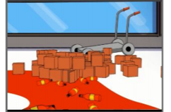

Make a list of all the forces that you noticed in the above table

