to the following website https://www.amnh.org/explore/ology/earth/plates-on-the-move2
- Watch the quick video about the various plate boundaries make sure to choose CC (closed captions) as you watch
- Use the graphics and animation to complete what happens during the 4 plate interactions
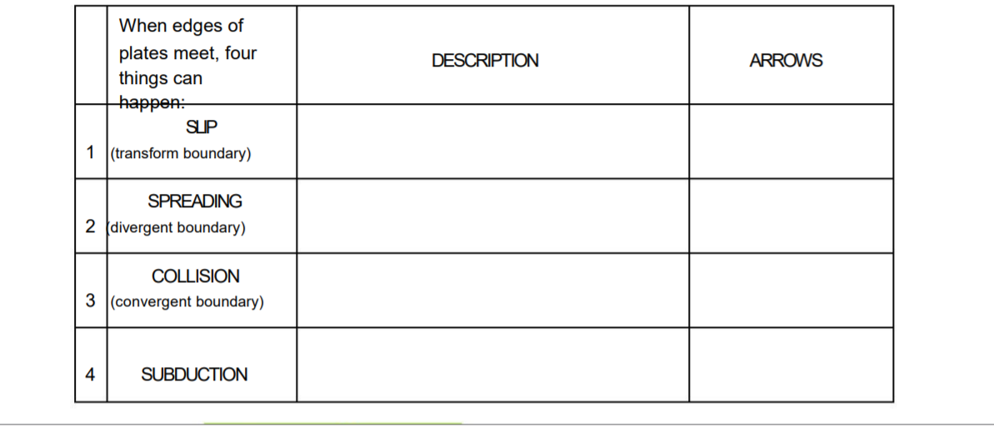
Once you finish completing the graphic organizer Click on the following link ( It is not really a game but it shows you places where plate interactions have really occurred around the world) Choose 2 locations to write about on page 2
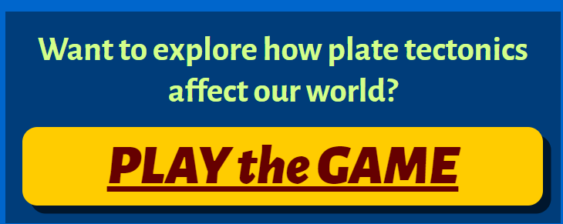

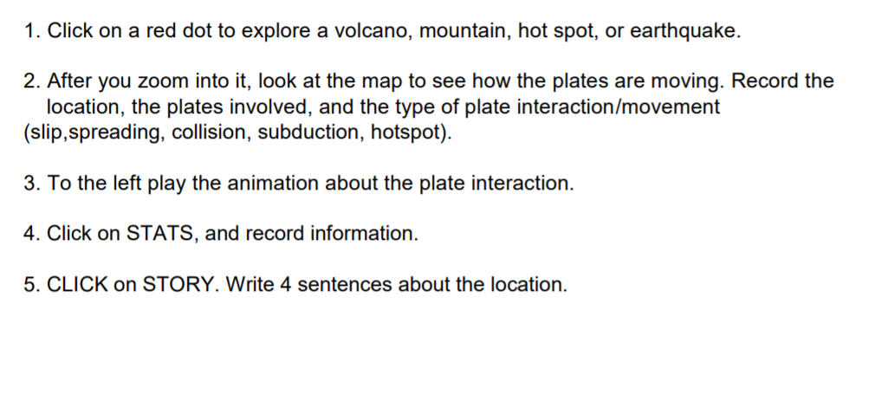

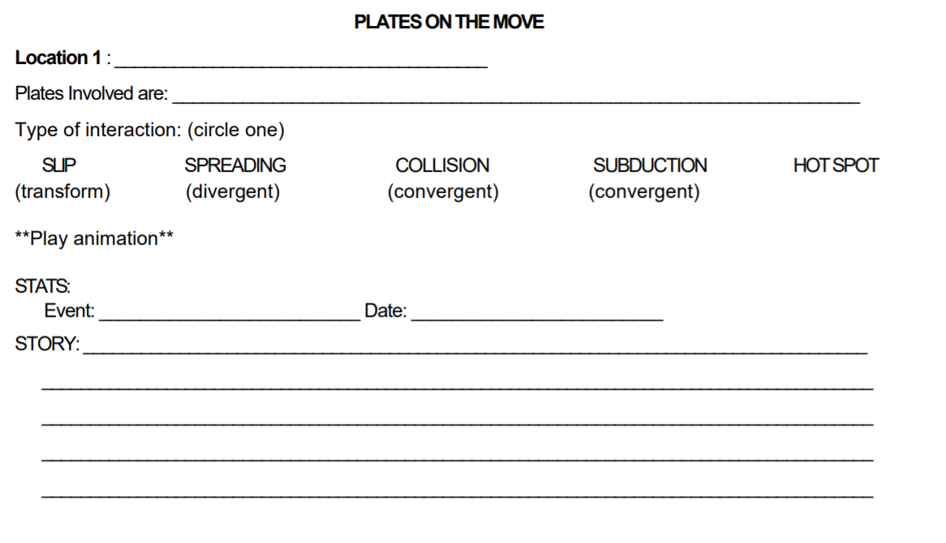

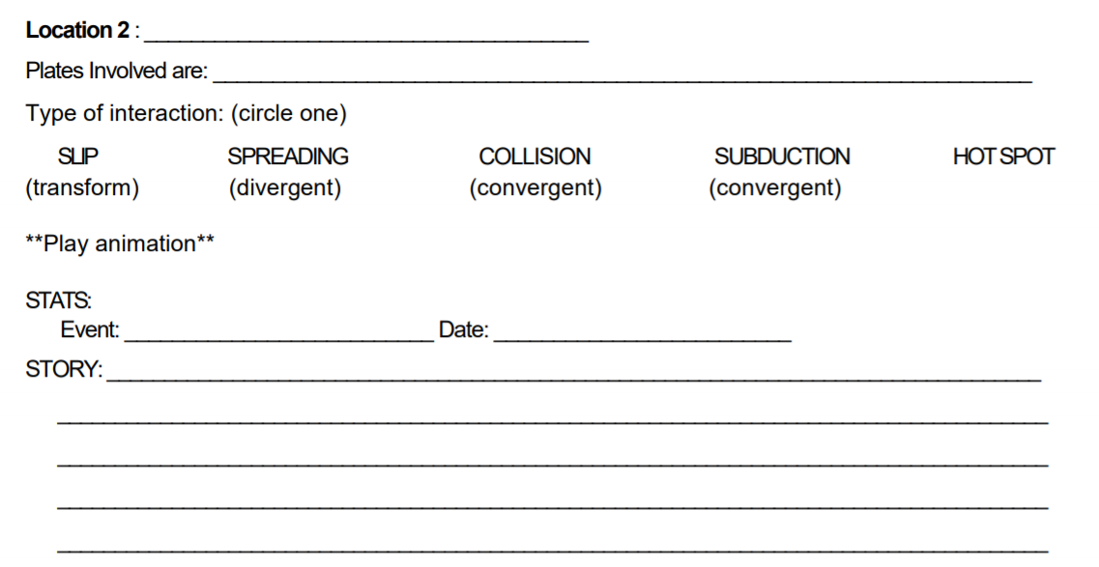

You must write down this information or print it on paper as you will have to enter what you learned about the two locations you choose in a Microsoft Forms Document to prove you completed the assignment.

