MASS AND WEIGHT
Definition of Weight is a measure of the gravitational force exerted on an object times the object’s mass. Weight is measured using a scale and the SI unit of force is the newton (N).
On Earth, gravitational force keeps objects from floating. The more mass an object has, the greater the gravitational force on the object and the greater the object’s weight.
Explain
Would your weight be the same if you were able to weigh yourself on Jupiter or Earth’s moon? Explain why.___________________________________________________________________________________________________________________________________________________________________________________________________________________________________________________________
Differences between Mass and Weight
MASS | WEIGHT

Density
Density is defined as _______________ per unit _____________________. It is a measure of how tightly packed and how heavy the molecules are in an object. Density is the amount of ___________within a certain ________________.
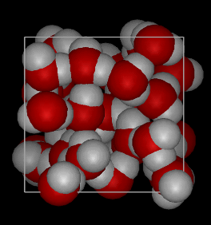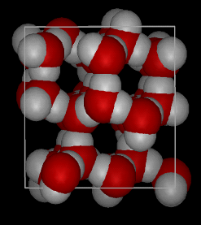
Answer the Questions Below
__________________________________________________________________________________________________________________________________________________________________________
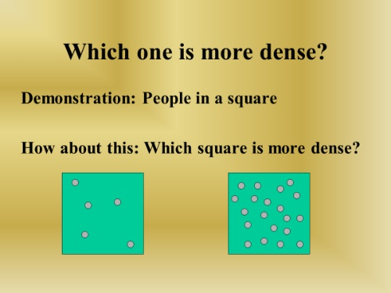
Answer the question below_____________________________________________________________________________________________________________________________________________________________________
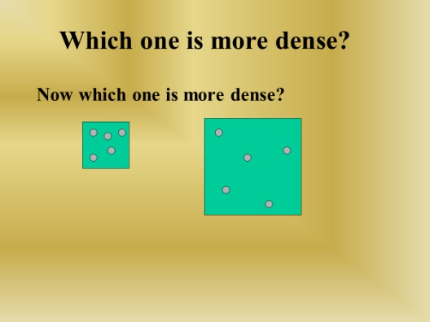
To Find Density
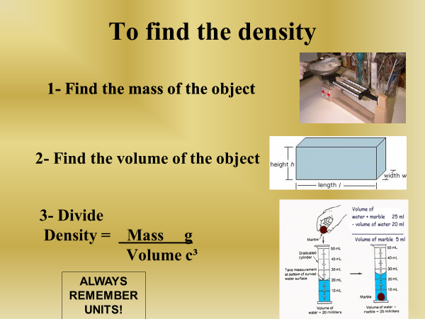
Practice (Find the Density of the object below)
If the mass of an object is 35 grams and it takes up 7 cm3 of space, calculate the density.
